**Student Name: Shinde Smita Shahaji**

**UID: 20BCS4643**

**Date of Performance: 08/04/2021**

**Branch: CSE_IOT Section/Group: IOT_B**

**Subject Name-Digital electronics**

**Aim**

**Design a pulse width modulated signals generator using 555.**

**Task to be done**

*(Objective of the task to be explained)*

Design traffic lights using D Flip Flop.

**Requirements**

*(Hardware and software requirements)*

# Software –

Tinker cad.

# Hardware –

|  |  |  |
| --- | --- | --- |
| sr.no | Apparatus | Quantity |
| 1. | 555 timer IC (NE555) | 1 |
| 2. | D flip flop IC (7474) | 1 |
| 3. | 5V Power Supply | 1 |
| 4. | Breadboard | 1 |
| 5. | Connecting wires | As per requirement |
| 6. | Arduino uno3 | 1 |
| 7. | 110 Ω Resistor | 3 |
| 8. | Red LED | 1 |
| 9. | Yellow LED | 1 |
| 10. | Green LED | 1 |

**Circuit diagram/ Block diagram***(Insert circuit diagram here)*

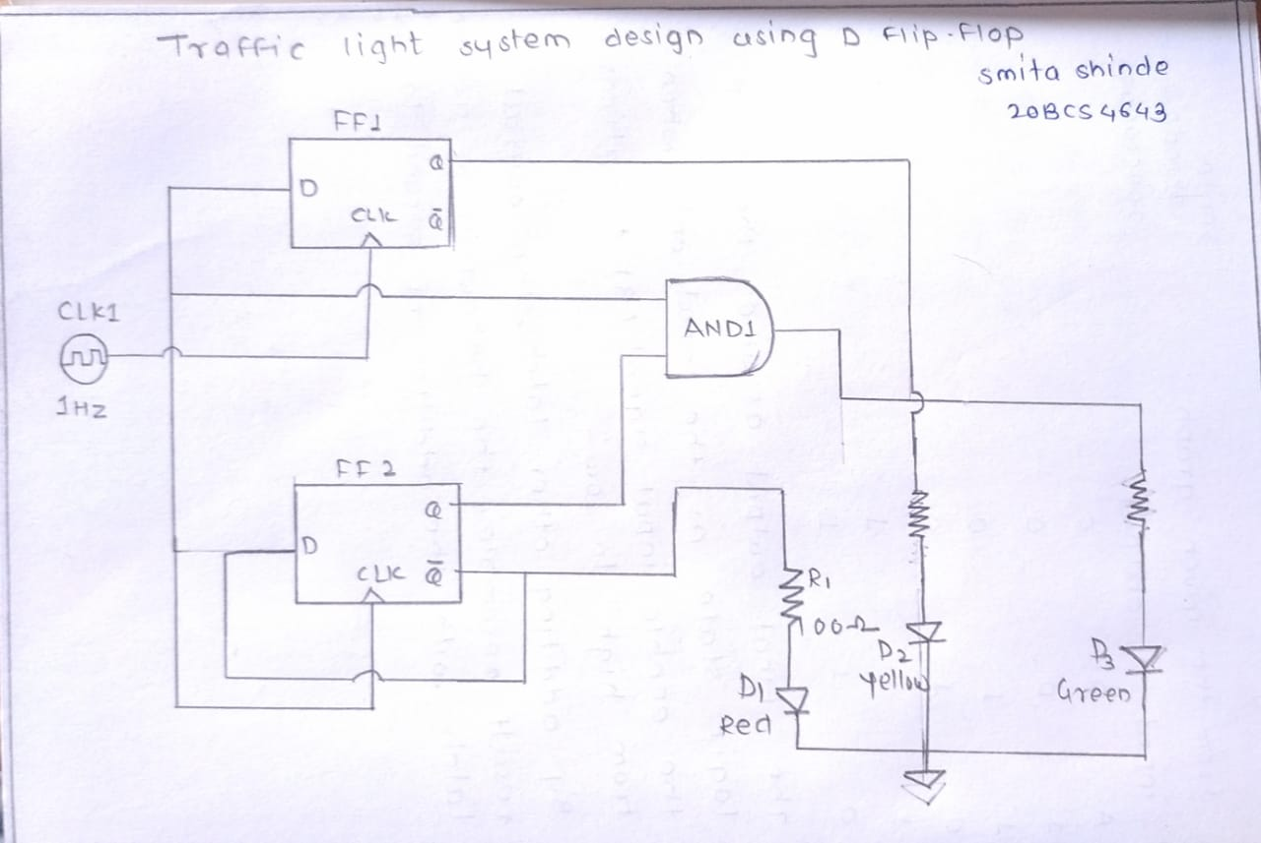

**Simulation Results:***(Insert simulation results)*

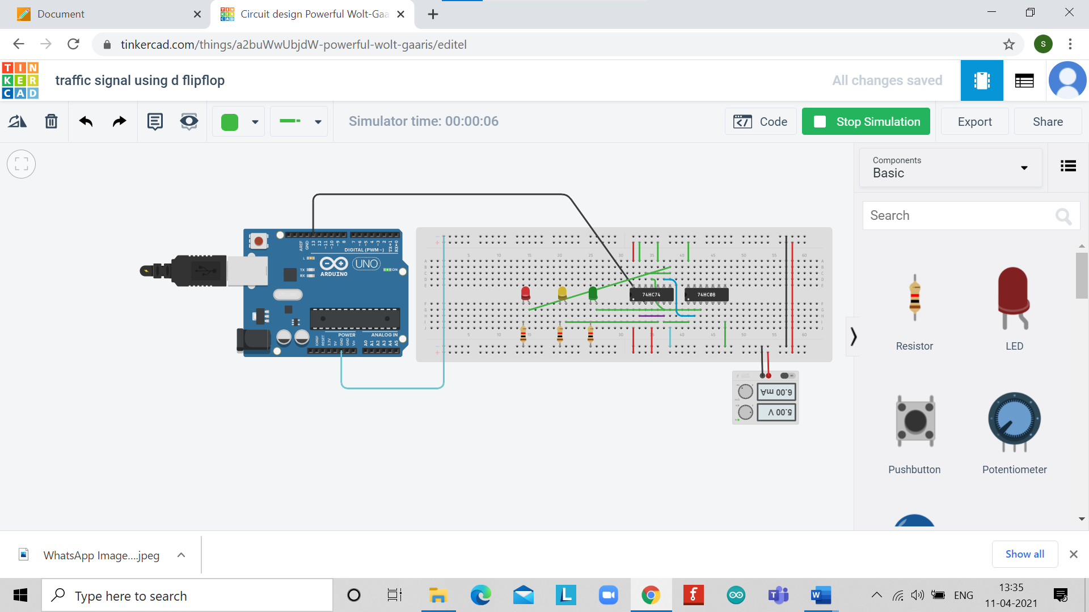

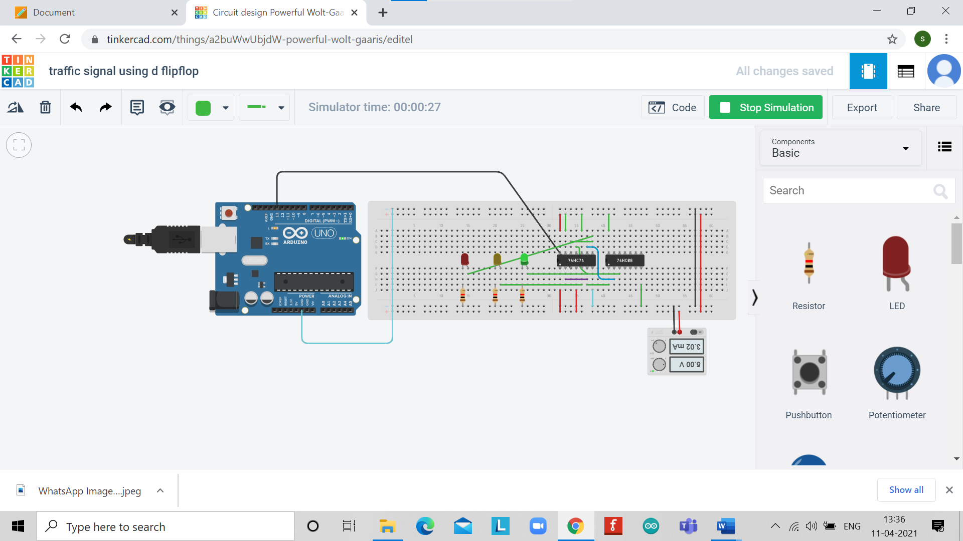 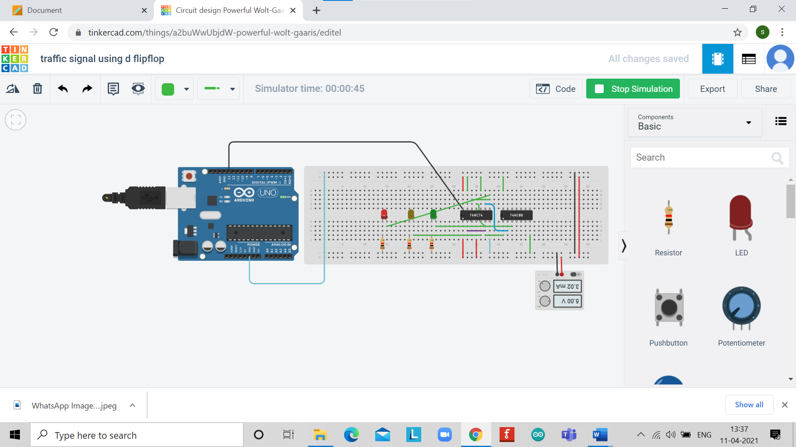

**Concept used**

*(Point out the concepts used in order to design the solution)*

* Basically, D flops follow the input when the clock is enable i.e. it take enable as a positive edge trigger and remain in the previous state when clock is disabled.
* Initially Input at flip flop 1 is 0. Input at flip flop 2 is 0.
* So, if you code Q of first flip flop as green led, Q' of second flip flop as red led and yellow led is coded to the combination Q' of first and Q of the second. At the first positive edge trigger you give input as 0 to flip flop 1 so the output is also 0 and the output at Q' which is 1 will act as a positive edge trigger at flip flop 2 which will again give input as 0 to Q of flip flop 2 so the output is also 0 and the output at Q' of flip flop 2 which is 1 will turn ON the red led connected to it.
* After first positive edge: Input at flip flop 1 is 1 (equal to Q' of flip flop 1) Input at flip flop 2 is 1.
* At the second positive edge: At flip flop 1 the input 1 is given to output Q which is connected to yellow LED and Q' turns 0 giving the clock at flip flop 2 a 0, turning the red led OFF.
* After second positive edge Input at flip flop 1 is 0 (equal to Q' of flip flop 1)Input at flip flop 2 is 1.
* At the third positive edge at flip flop 1 the input which is 0 is given to the output which is also made 0 and the output at Q' which is 1 will act as a positive edge trigger at flip flop 2 which will again give input as 1 to Q of flip flop 2. Now Q of flip flop 2 and Q' of flip flop 1 which are both at 1 will give 1 to the yellow LED turning it on.
* And the loop will continue.
* Now once led glows make sure that the next positive edge trigger will come after the required time in other words change the frequency of clock pulse according to your requirement (you can use 555 timer to generate required clock pulse) so that LED will stays glowing and after that particular time give 1 as Input at positive edge of the clock the other LED glows and maintain the same clock frequency.

**Learning/ observation**

*(Observations made during the experiment and learnings for future reference)*

* The practical applications of D flip flop in designing traffic lights are studied and implemented. Using two D flip flops and one AND gate we designed the traffic lights and made its implementation on the tinker-cad software.
* It is a simultaneous process in which the clock signals are generated. once red-light glows then yellow light glows then the green light starts glowing. after green light-yellow light does not glow and directly red light starts glowing instructing the vehicles to stop.

**Troubleshooting**

*(Problems encountered and how did you solved those)*

The only problem I faced was the how the connections are to be made in the tinker-cad implementation but with the help of circuit diagram I was able to solve the problem.